Lesson Plan – Day 24

Lecture

Explain the difference between the following Geometric concepts:

Parallel Skew

Perpendicular

Then, explain the following Geometric concepts:

Transversal Alternate Exterior Angles

Corresponding Angles Alternate Interior Angles

Consecutive Angles

Assignment # 24

- Complete the following statements about the transversal below with regard to corresponding, alternate interior, alternate exterior, or consecutive angles:

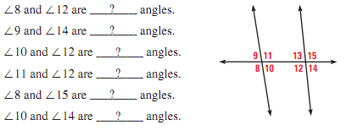

- Draw two parallel lines. How do you know they are actually parallel? Next, draw a transversal. Identify a pair of alternate interior angles in your diagram

- Think of each segment in the diagram as part of a line. Fill in the blank with parallel, skew, or perpendicular:

- Write the Roman numeral that consists of the indicated segments:

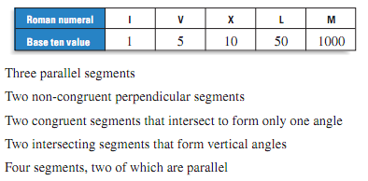
5.

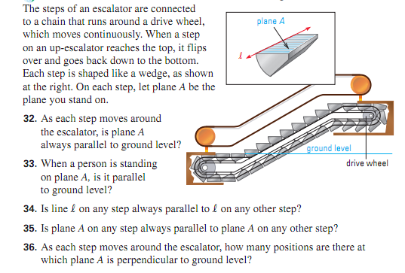
- What are two unique properties of perpendicular lines? Draw an example below:

