Triangle Sum Theorem

Materials Needed: One Triangle Per Person, One Piece of Binder Paper Per Person, Pencil, Scissors

Part 1: Triangle Sum By Trial (10 minutes)

- Each person in the team should cut out 1 triangle (one person has A, one has B, …)
- Tear off the 3 angles of your triangle (the corners – one person has 3 A pieces, 3 B pieces, …)
- Draw a horizontal line on the top of your binder paper, with a dot in the center like this:

- Fit the three angles, side by side, on the top of the line with all three arrows pointing at the dot.
- Compare your picture with your partner. What did you discover about the angles in each of your triangles? Finish the sentence in your notes:
“From this activity, we think the angles in any triangle__________________________________.”
- Check in with the teacher! Be ready to explain
what you noticed about the angles in a triangle.

Part 2: Using The Relationship! (15 minutes)

Find x in each diagram below. Show all of your math work step-by-step on your binder paper!
  - b.
2x°
96°
x+12°
80°
40°
x°

c. Find the number of degrees in the “ ? ” mark. Remember what we learned about supplementary and vertical angles! Then, write an explanation about how you found it – peanut butter and jelly style. Make sure to include a “because” in each sentence.
35°°
°
100°
?

Part 3: Lots of Angle Chasing! (15 Minutes)

For each problem below, find the measure of the missing angle. Write what you figured out step by step.

I know that… | Because…

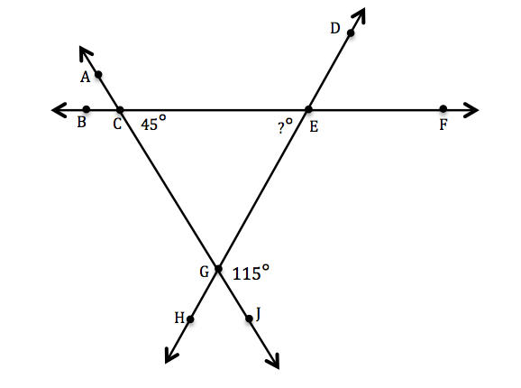
1.

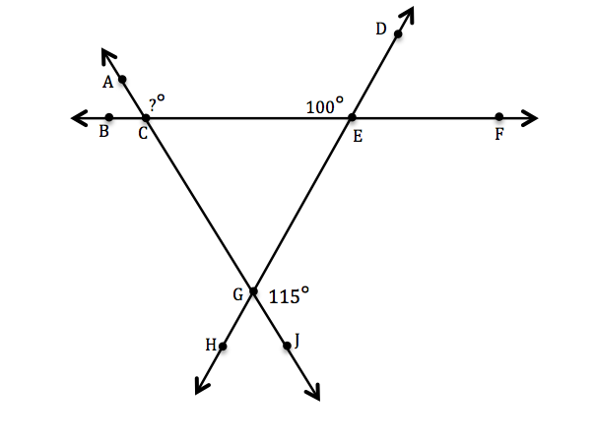
2.
Statements | Reasons

B
A

D
C

