Lesson Plan – Day 22

Lecture
Explain the concept of a “two-column proof” to students. A proof is a logical layout that includes statements & reasons.

Then, give students the hand-out entitled, “9 Important Geometry Theorems”.

Name of Theorem | What does it mean?
Reflexive Property | A side or angle is exactly the same as itself.
Transitive Property | If A = B and B = C, then A = C.
Substitution Property | If A = 4, then anywhere A can be replaced with 4.
Algebra Property | You can perform any operation to BOTH sides of an equation!
Vertical Angles Theorem | If two angles are vertical angles, their measures are congruent.
Complementary Angles Theorem | Two angles are complementary if their sum is 90 degrees.
Supplementary Angles Theorem | Two angles are supplementary if their sum is 180 degrees.
Triangle Sum Theorem | If it’s a triangle, the sum of the interior angles is 180 degrees.
Definition of Midpoint/Bisector | Splits a segment or angle into two congruent pieces.

Assignment # 22
(Two-Column Proofs)
1. Fill in the missing information:
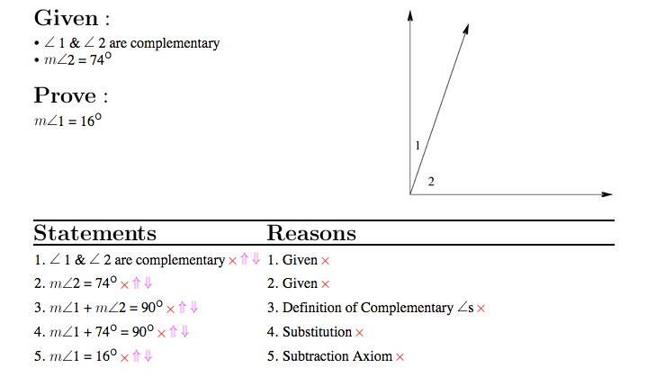
2. Read This Proof. Explain in words what the proof-writer is talking about. Your explanation should answer the questions:

1) What is the reflexive property?
2) Why did the proof writer need to use it?
3) What does “addition property of equality” mean in normal terms?
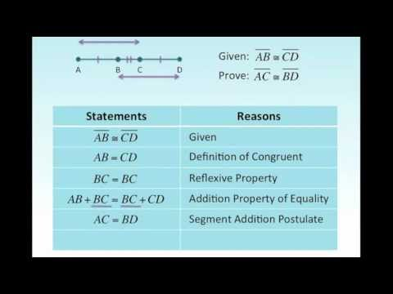

3. Fill in the missing information:
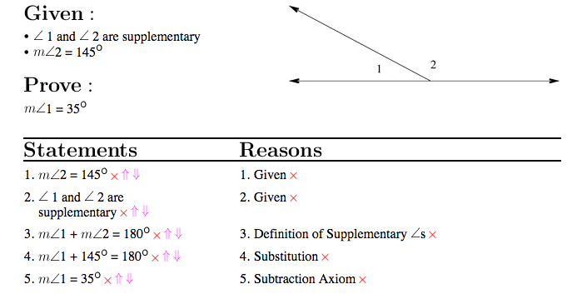

4. Match these conditional statements with their property of equality:
If JK = PQ and PQ = ST, then JK = ST. A. Addition property
If m<S = 30°, then 5° + m<S = 35°. B. Substitution property
If ST = 2 and SU = ST + 3, then SU = 5. C. Transitive property
If m<K = 45°, then 3(m<K) = 135°. D. Symmetric property
If m<P = m<Q, then m<Q = m<P. E. Multiplication property

5. Prove that m<ABC = 2 (m<DBA)
Given that m<DBC = m<DBA

