Assignment # 21
(Important Geometry Symbols)

- How would you show that the figures below have been bisected? Explain what your symbols actually mean:

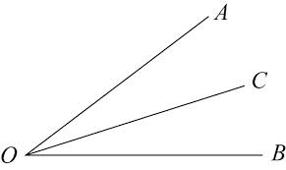

Q T

- Draw all necessary marks on the figure below, showing that it is a rectangle. Explain what your symbols actually mean:

- Draw an equilateral triangle below. Then, show its altitude going straight up. Finally, indicate that the height bisects the base:

- Describe what the symbols in the diagram below mean:

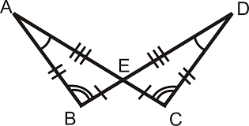

- Restate the sentence below as a conditional statement. Then, write its converse, inverse, and contrapositive:

Mr. Aidi is not funny!

Conditional:

Converse:

Inverse:

Contrapositive:

- Use symbolic notation to express the exact same statements you made above:

Conditional:

Converse:

Inverse:

Contrapositive:

