Lesson Plan – Day 20

Lecture
- Define a “conditional statement” as having 2 parts: a hypothesis & a conclusion. These statements usually come in “if-then” form.

Examples

- If a fish is a shark, then it has a boneless skeleton.
- If x²=16, then x=4.

- Review the concepts of:

Converse (switch if with then)

Inverse (negate conditional statement)

Contrapositive (negate converse)

Bi-Conditional (if and only if)

- Team Activity:
You just watched a five-minute movie scene from Alice in Wonderland, by Lewis Carroll. You may recall that there was a debate between Alice, the Mad Hatter, and the March Hare that went like this:
“Then you should say what you mean, “ the March Hare went on. “I do,” Alice hastily replied, “at least I mean what I say—that’s the same thing, you know.” “Not the same thing a bit!” said the Hatter. “Why, you might just as well say that ‘I see what I eat’ is the same thing as ‘I eat what I see’!”
Your team must now discuss why the Mad Hatter is disputing with Alice over the precise use of language.
Students will be expected to:
- Turn each argument into a conditional statement, converse, inverse, and contrapositive.

- Validate the Mad Hatter’s contention with real-life examples, or negate his argument with real-life counterexamples

Assignment # 20

Rewrite the conditional statements below in “if-then” form. Then, write a converse, inverse, and contrapositive for each:

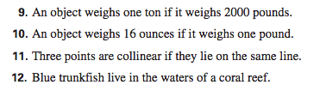

Decide if the statements below are true or false. If false, then provide a counterexample:

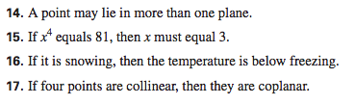

Determine if the Algebraic statements below can be written as true bi-conditional statements. Use mathematical reasoning to show why or why not:

