Lesson Plan – Day 7

Lecture
- Define “inductive reasoning” as a form of logic based on observable patterns & conjecture (unproven prediction). Define “counterexample” as example that proves a conjecture is false.

- Define “deductive reasoning” as logical argument that uses facts, definitions, and already accepted terms.

Examples:
- Arm-wrestling the same person and beating them time & time again (Inductive).

- Arm-wrestling 2 different people and proving indirectly that because you are stronger than one person, you are also stronger than the other (Deductive).

- All apples are fruits. All fruits grow on trees. All apples grow on trees. (A=B and B=C, therefore A = C)

- A durian fruit can knock you unconscious, because of gravity. (Logical leap based on known facts)

Assignment # 18

- What is a “conjecture”? What kind of reasoning is associated with it? Explain the concept by citing a real-life example:

- How can you prove that a conjecture is false?

Describe the pattern in the sequence of numbers below. Then predict the next number in each pattern:

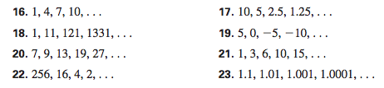

Sketch the next figure that should appear in each pattern below:

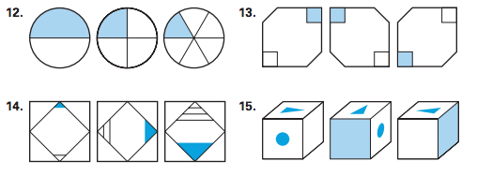

Prove the conjectures below are false by providing a counterexample for each:

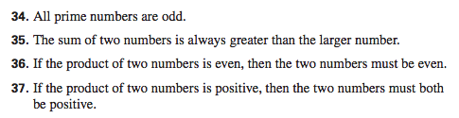

19. Cite a time you have used “deductive reasoning” in your life. How did it help you in that instance?

20. Give an example of “deductive reasoning” that is used in our math class. What kind of information are you relying on in this case?

