Assignment # 16: transformers Name: ___________________________________
Block: _______

1. Label this shape ABC. 2. Label this shape DEFG. 3. Label this shape HJK.
Reflect it over the x-axis. Reflect it over the y-axis. Translate (x,y x - 3, y + 4)

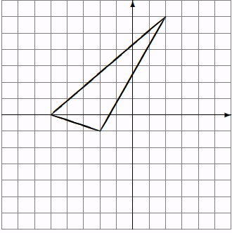
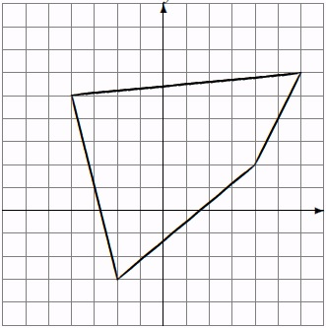
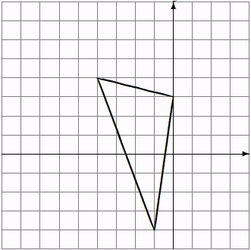

Write the coordinates below: Write the coordinates below: Write the coordinates below:

A: ____________ A’: ____________ D: ____________ D’: ____________ H: ____________ H’: ____________
B: ____________ B’: ____________ E: ____________ E’: ____________ J: _____________ J’: ____________
C: ____________ C’: ____________ F: ____________ F’: ____________ K: ____________ K’: ____________
G: ____________ G’: _____________

4. Label this shape LMNP. 5. Label this shape QRS. 6. Label this shape TUVW.
Translate it (x – 1, y – 2) Rotate it 90° clockwise Dilate it (x, y) (-1.5x, -1.5y)
about the origin.
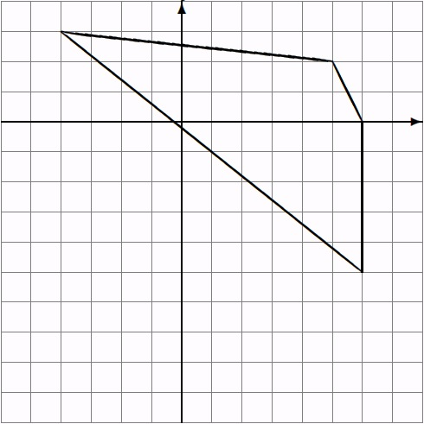
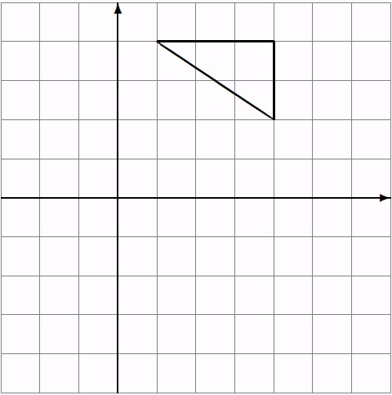
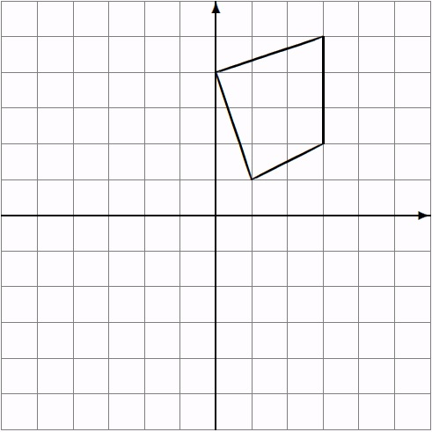

Write the coordinates below: Write the coordinates below: Write the coordinates below:

L: ____________ L’: ____________ Q: ____________ Q’: ____________ T: ____________ T’: ____________
M: ____________ M’: ____________ R: ____________ R’: ____________ U: _____________ U’: ____________
N: ____________ N’: ____________ S: ____________ S’: ____________ V: ____________ V’: ____________
P: ____________ P’: _____________ W: ____________ W’: ___________

Rotato Potato
