Assignment # 14

1. 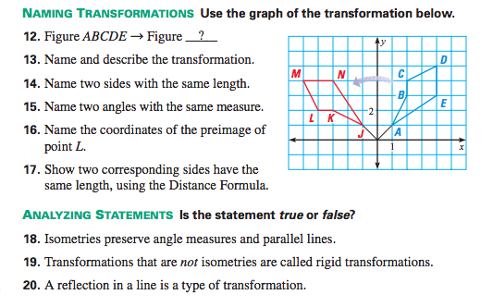
- Name the transformations that map footprint A unto the other steps:

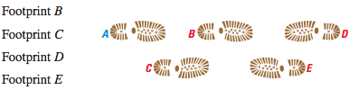

3. 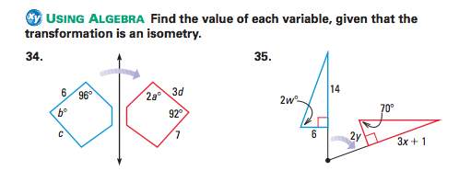

4. Transform triangle PQR below, using 4 different techniques:
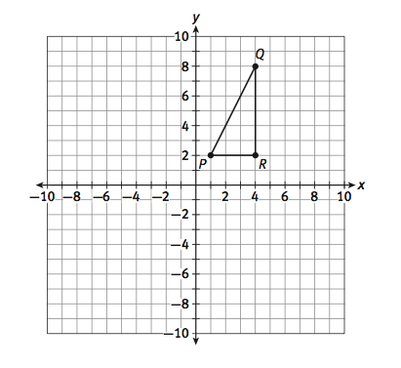
- Name each transformation you used

- Classify each transformation as either “rigid” or “non-rigid”

- Come up with a function rule for each unique transformation

- What pattern do you notice with each function rule?

