Assignment # 13

1. 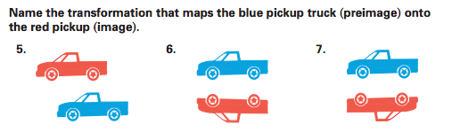

2. Are the transformations below “rigid” or “non-rigid”? Explain each of your answers in detail:

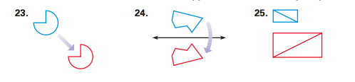

3. How many lines of symmetry exist in each of the flowers below? Draw them please:

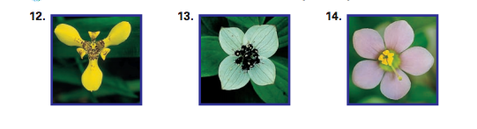

4. Do the shapes below have rotational symmetry? Why or why not? If so, by how many degrees?

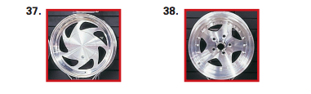

5. How many lines of symmetry do the flags below from various countries have? Justify your answer:

Cuba

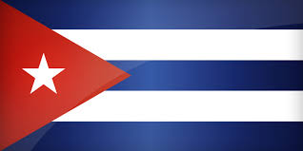

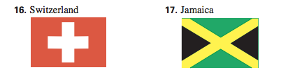

6. Identify the transformation below. Then, describe its scale factor:

