Assignment # 12
(UNIT 1 MASTERY)

The purpose of this is to let you know where you are at and what you need more practice at to become a master of Intro Geometry.

Skill #1: Naming Points, Lines, Planes & Angles  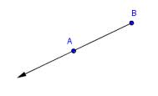  What type of geometric object is this? ________________________  Write down all of the names that make sense for this object: | Skill #2: Measuring with a Ruler & Protractor  A  B  C  D  E  F  G  H  I  Find the length of segment AD.____  Find the measure of angle DHB:______  Find the measure of angle DIE:_____
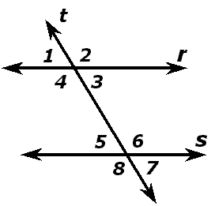
Skill #3: Describing Angles and Their Properties

- What two angles are supplementary to angle 7? ____ and ____

- If the measure of angle 7 were 47°, what would the measure of angle 5 be? _______ How do you know?

- If the measure of angle 7 were 62°, what would the measure of angle 6 be? _____ How do you know?

- Name all of the obtuse angles in the picture.

Skill #4: I can convert between different measuring scales
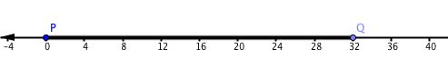

1) If I drive between points P and Q and each marker represents 80 miles, how long is the drive?

Skill #5: I can draw lines and plot points according to a description and vice versa

- J is the midpoint of $\overline{PQ}$. Label it on the diagram.
- R is the midpoint of $\overline{JQ}$. Label it on the diagram.
- BONUS (not counted): What fraction of $\overline{PQ}$is $\overline{PR}$

Skill #6: I can find the midpoint of a segment  1) Find the midpoint of segment $\overline{AC}$ using any method you want.  Skill #7: I can find the distance of diagonal lines on the coordinate plane  1) Find the length of segment $\overline{AC}$ in units (1 unit = 1 human block). No rulers! Write your work on the back. | 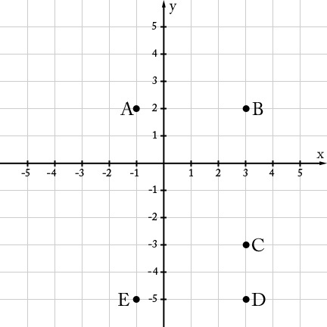

Skill #8: I can find the area and perimeter of the 4 basic shapes (rectangle, square, triangle, circle)

You CAN use a resource card for this!
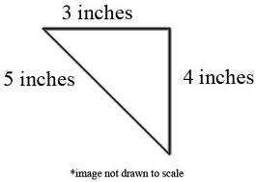
1) Find the perimeter and area of this triangle.

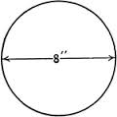
2) Find the circumference and area of this circle.

This feedback is given to you so that you can learn from your mistakes
and master these ideas.

Mastered Skill #1 (Geometric Names) Yes Not Yet
Mastered Skill #2 (Measuring with a ruler/protractor) Yes Not Yet
Mastered Skill #3 (Angle Properties) Yes Not Yet
Mastered Skill #4 (Converting Between Scales) Yes Not Yet
Mastered Skill #5 (Drawing Based On a Diagram) Yes Not Yet
Mastered Skill #6 (Midpoint) Yes Not Yet
Mastered Skill #7 (Distance) Yes Not Yet
Mastered Skill #8 (Area & Perimeter) Yes Not Yet

What’s one thing you are feeling successful at?

What’s one thing you want to make sure to watch out for on Thursday/Friday?

