Lesson Plan – Day 9

Lecture
- Explain difference between outside measurement versus inside measurement

- Examine the 4 most basic shapes in Geometry:

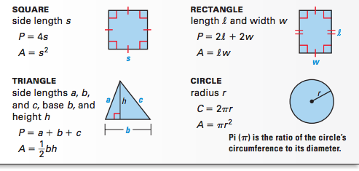

- Review Examples Problems 3, 5 and 6

Assignment # 9

(Area, Perimeter & Circumference)

Find the perimeter (or circumference) & area of each figure below:

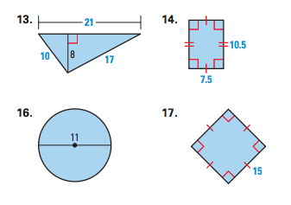

2. A triangle has an area of 52 square feet and has a height of 13 feet. What is the measure of its base?

3. How many square yards of carpet are needed to cover the floor of a room that is 15 feet by 25 feet?

4. Find the area & perimeter of the triangle drawn below:

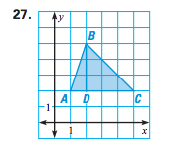

5. How many times does a bicycle tire that has a radius of 21 inches rotate when it travels 420 inches?

