Assignment # 6 (Where’s The Middle?)

Oh no! My dog has ran away & is precisely in the middle between points A and B. How could I figure out his exact location using 3 different techniques?

Method 1
Method 2
Method 3
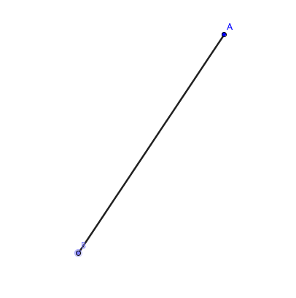

Method 1
Method 2

Now that you have more information with the grid provided below, find 2 more techniques for finding the middle.

