Lesson Plan – Day 5

Lecture
- Define vertical angles & linear pairs

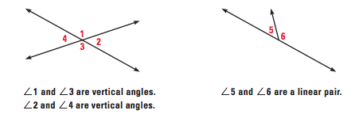

- Define complimentary angles & supplementary angles

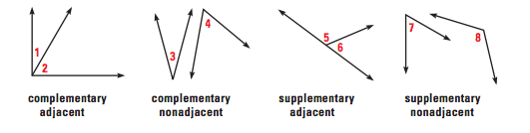

- Review Examples Problems 2, 3, and 6

Assignment # 5 (Angle Pair Relationships)

Answer the following questions, using the figure drawn below:

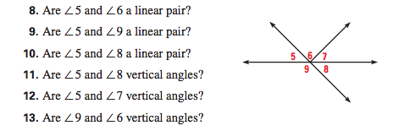

State whether the two angles shown on the clocks below are complimentary, supplementary or neither:

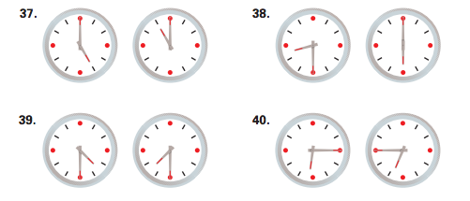

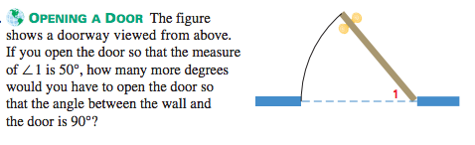

Find the missing angle measurements, using the figure drawn below:

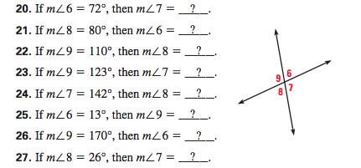

15. Fold a small piece of paper in half three times and label it as shown below:

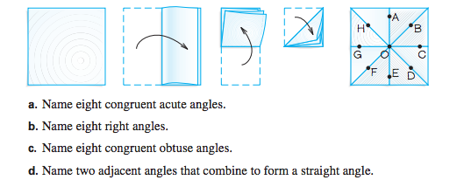

Use Algebra to find the values of the variables below:

