Assignment # 4

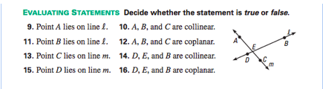

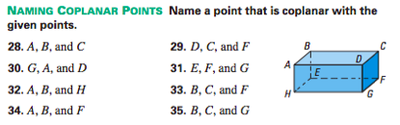

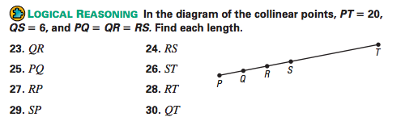

- Use Algebra to solve for the lengths of the segments below:

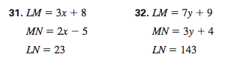

5. Write two names for each angle below. Then, measure each angle with your protractor to the nearest degree.

