Navigating In The Dark
(Assignment # 2)
Oh no! You can’t see the points anymore. How are you going to tell the pirates where to go? Work together to create accurate directions for other teams to follow. Here’s how:

1. Quickly draw a path route made of segments to get from Here to There. There is one segment started for you.

2. As a team, create directions for your pirate, who can’t see the path. Take turns measuring the angle you would need to turn and how far you would need to walk (in inches). (This part is tricky, so have the rest of the team confirm each measurement). Make sure everyone agrees (and can explain how to find) each measurement, and then record the direction on your directions card.
3. When your group is finished, call a teacher over for a checkpoint. Anyone in the group can be called on to explain how your directions match your map!

Sample Set of Directions
Directions from Here to There.
Start at Here:
- Move 1 7/16 inches along the 0° line.
- Turn 37° to the left and travel 2 ½ inches.
- Turn 85° to the right and travel 3 5/16 inches.
- Turn 120° to the left and travel 2 ¼ inches.
- Turn 22° to the right and travel 1 inch.
Arrive at There.

Part 2: Your Own Map

- When your team has finished the checkpoint, give each person at your group their own map.

- Each person should draw the pirate route and write a set of directions to get from “Here” to “There” on a separate sheet of paper. You are allowed to ask teammates questions and to check your measurements, but they are going to have to follow your path (so don’t give too much away).

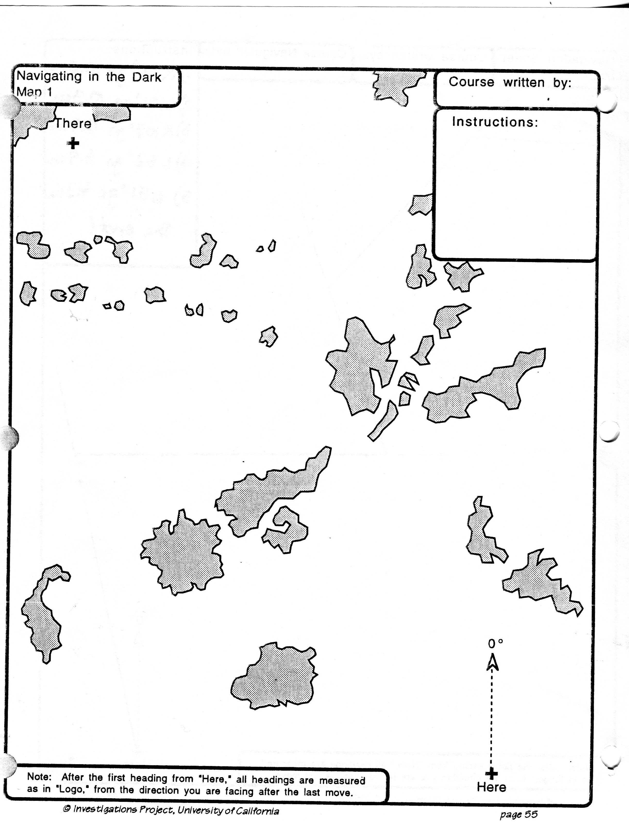
Map #1

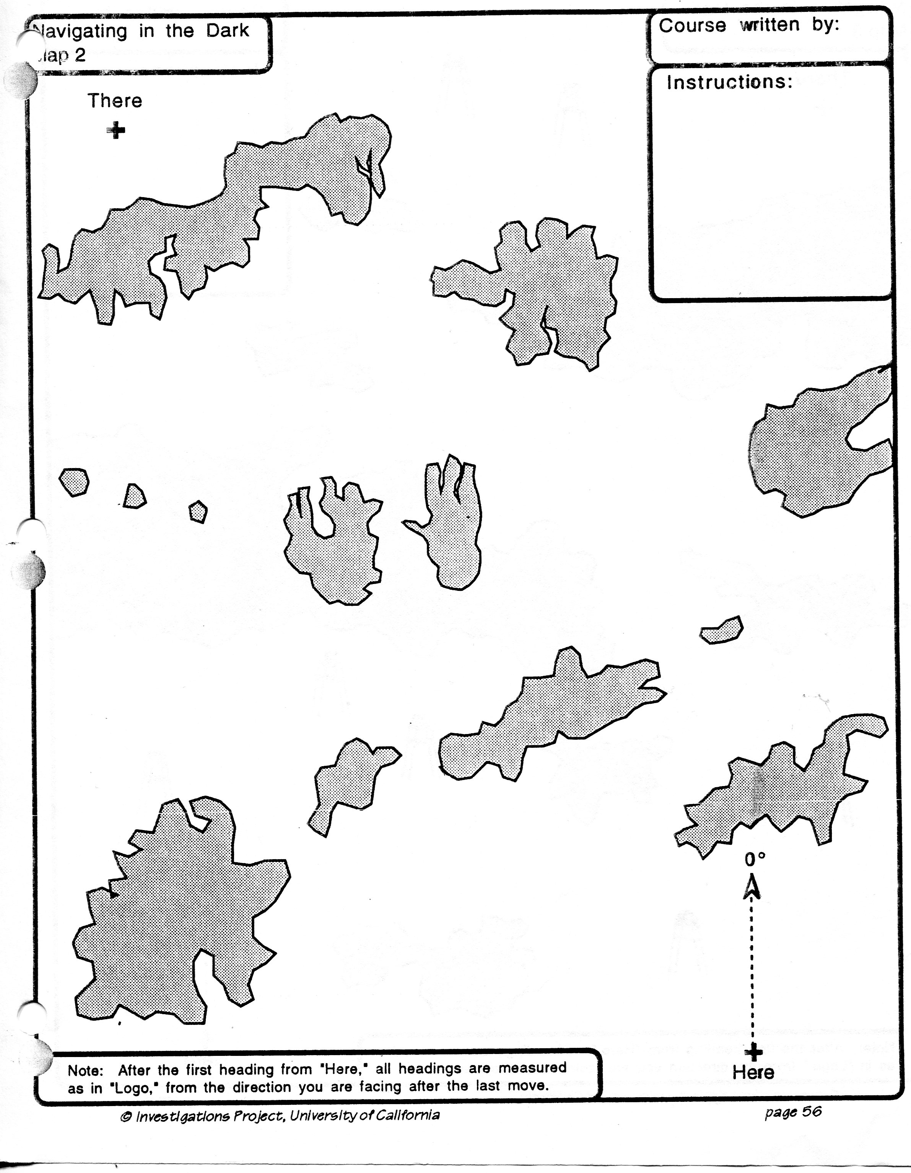
Map #2

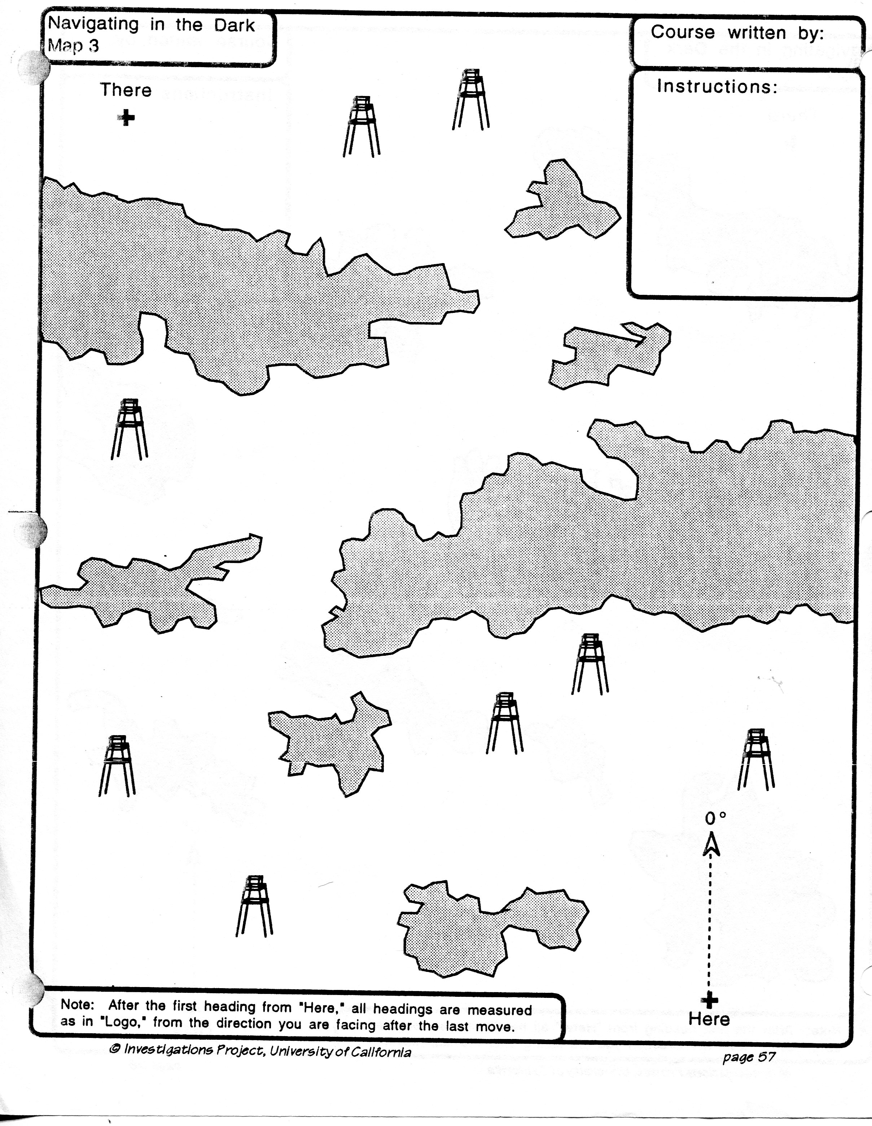
Map #3

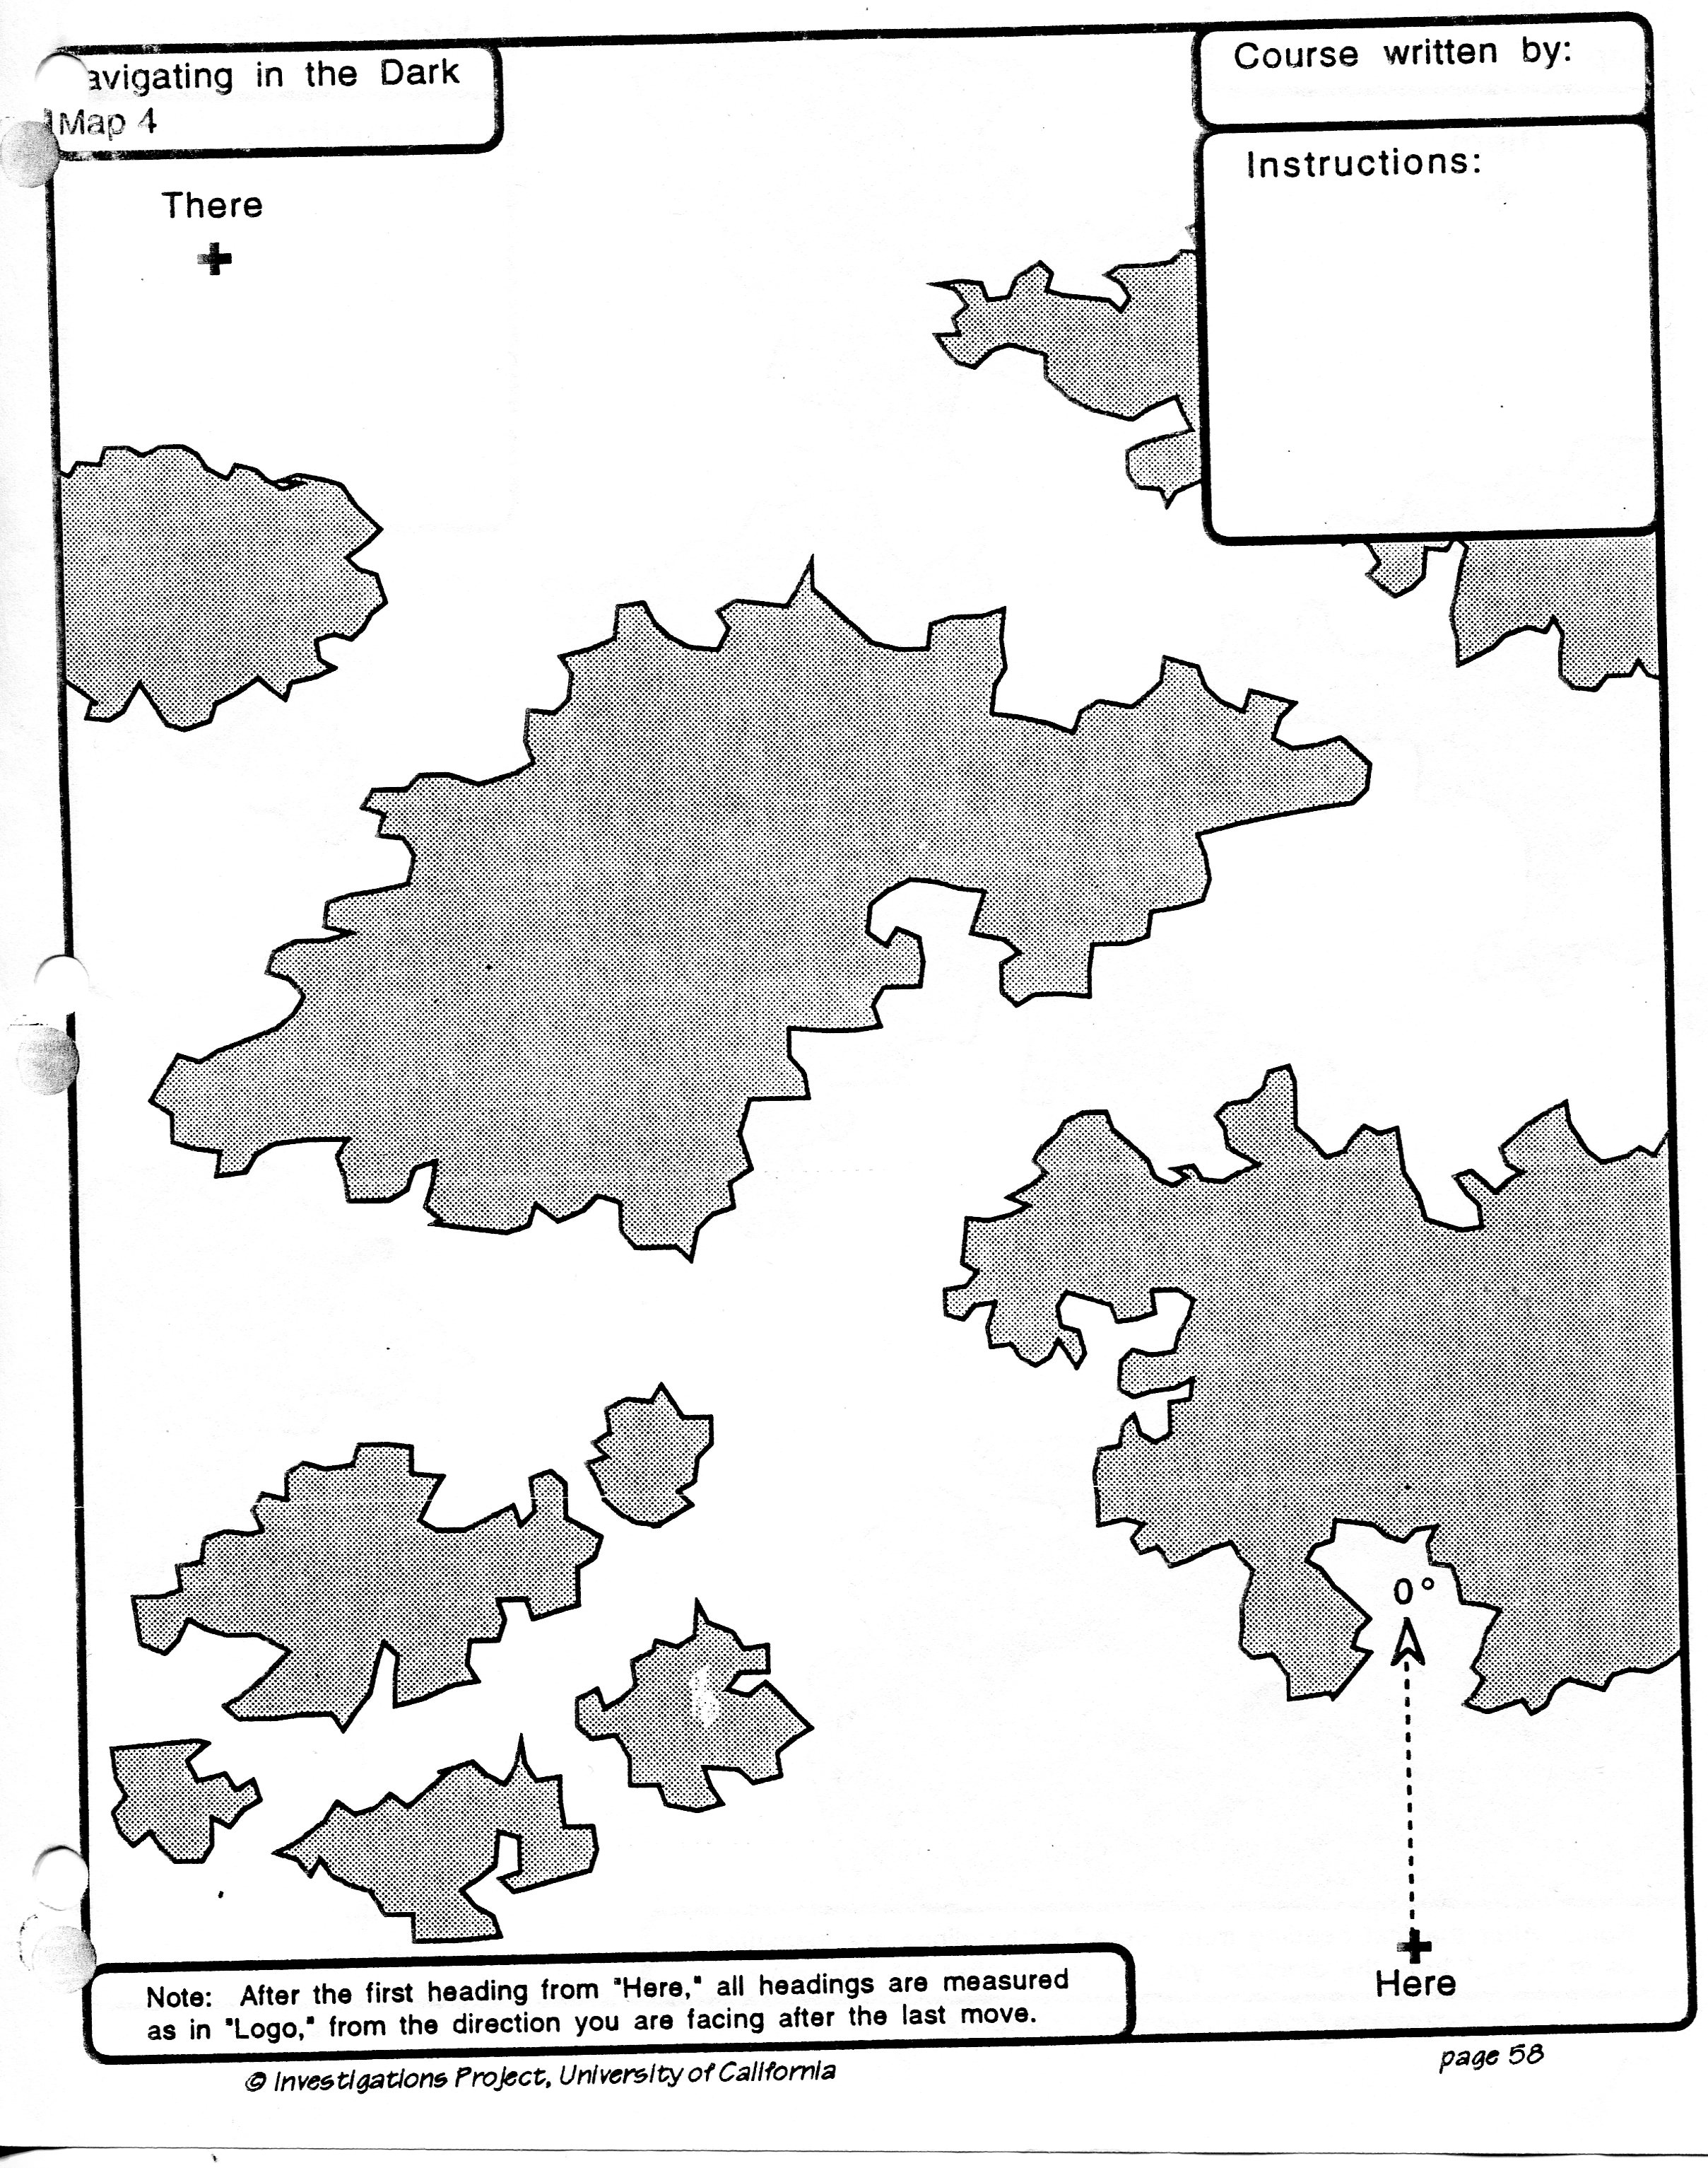
Map #4

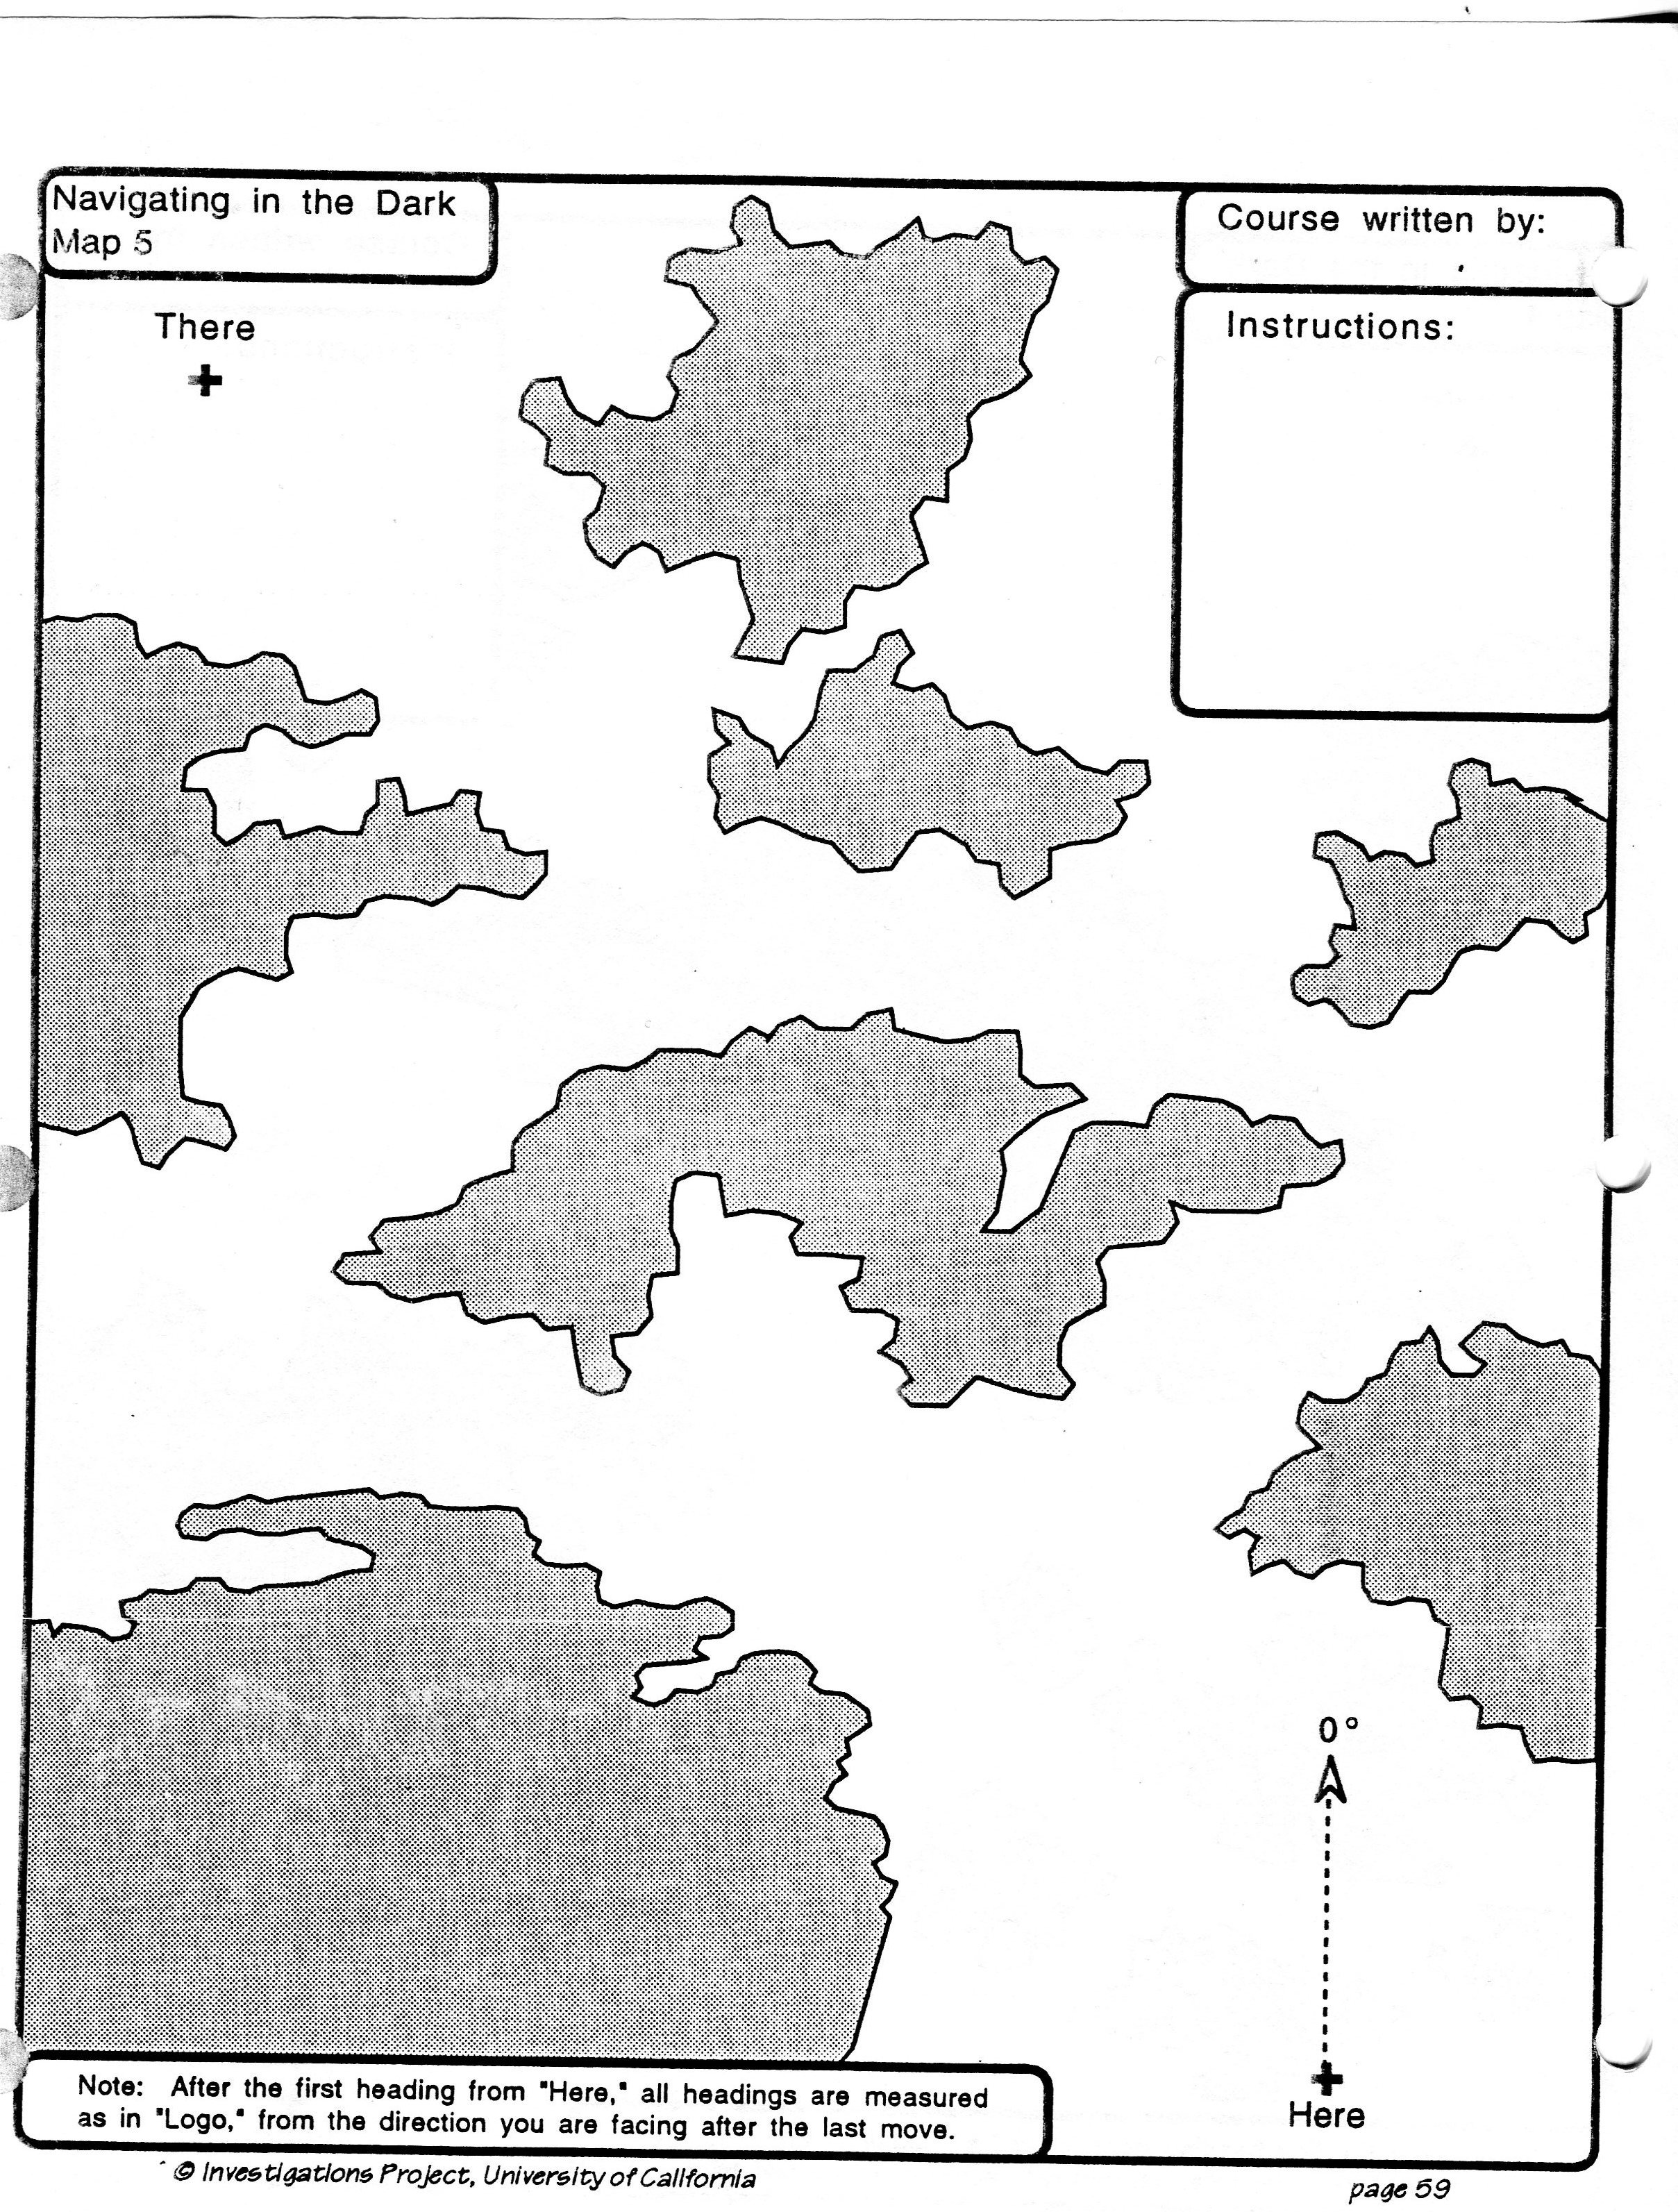
Map #5

