Navigating In The Light
(Assignment # 1)

Your Task: Work together to draw all possible pirate paths between points. A pirate path is a straight path that either passes through or stops at points on the map.

There are 2 Rules:
- Your path goes on forever unless an island blocks it.
- If an island blocks your path, the path stops at the closest labeled point.

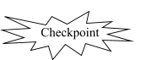
Take turns drawing paths, one at a time. While one person is drawing a path, another’s job is to describe what kind of path he/she is drawing. “I know you’re drawing a ray because…” A third person should write the name of the path on your map.

Check in with your teacher when you have drawn all possible paths! Make sure everyone can explain how you drew each one and its proper name.

Here are some important geometric words that might help you to be successful at this task.

 | 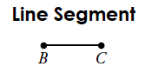 | 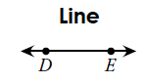 | 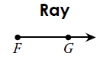
$$\dot{A}$$ | $$\overline{BC}$$ | $$\overset{⃡}{DE}$$ | $$\vec{FG}$$

Your Voyage

Ahoy! Write a pirate log using your new vocabulary that describes a pirate path from Here (Point H) to There (Point T). Your path must travel along at least:
- 1 line
- 1 ray
- 1 segment

Use the sample pirate log below as an example:
Directions from port L to port D.
Leave Port L:
- Travel along ray $\vec{LK}$ to point $\dot{W}$.
- Follow segment $\overline{WN}$ to point $\dot{N}$.
- Follow ray $\vec{NE}$ to point $\dot{E}$.
- Travel along line $\overset{⃡}{XC}$ to point $\dot{C}$.
- Follow segment $\overline{CD}$ to point $\dot{D}$.
Arrive at Port $\dot{D}$.

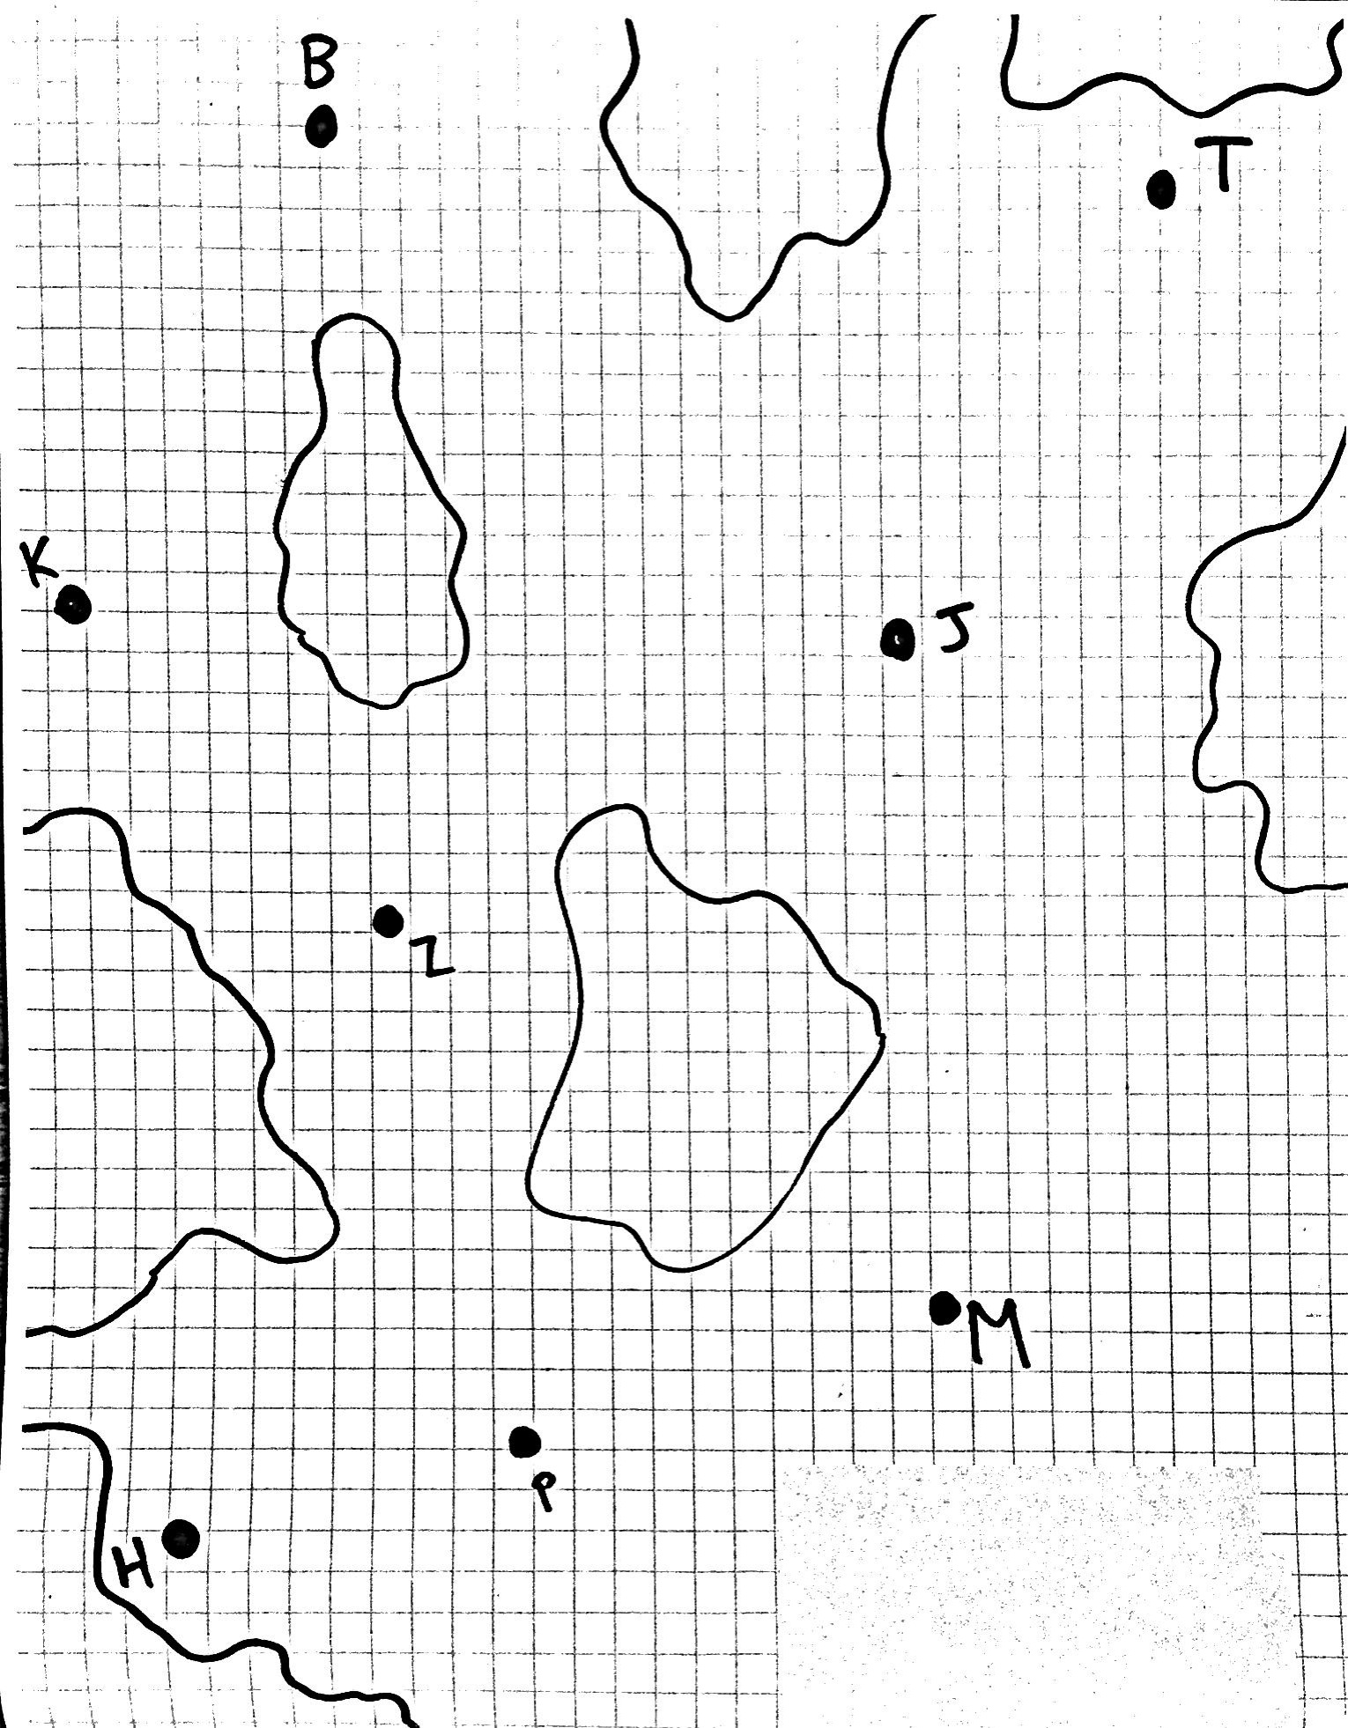
Pirate Map

